Words Talk Numbers Scream! Part1
by Paul Mourino 3.3.25
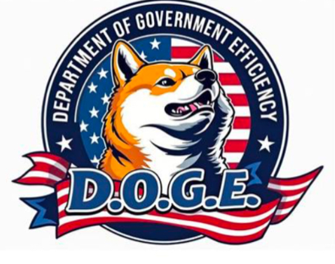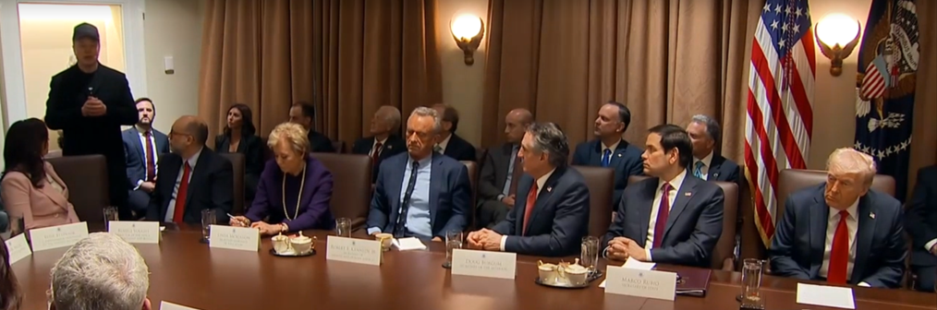

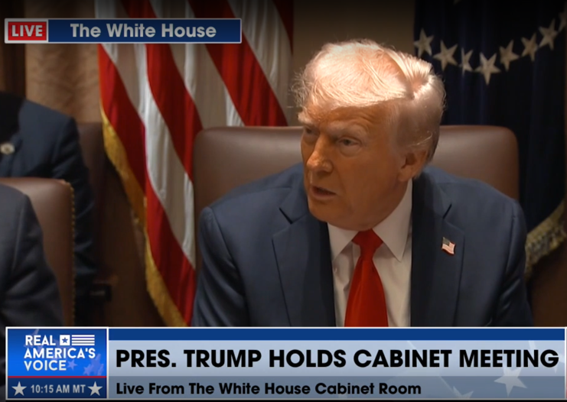

History was made, Wednesday 2.26.25, as President Trump convened his first public cabinet meeting at the White House. It was a tour de force. Opening pleasantries were led in prayer to the Almighty, by the H.U.D. Secretary Scott Turner (housing & urban development) followed by President Trump outlining the mission for a balanced budget & reduced federal spending. Elon Musk spoke next outlining DOGE’s Mission & recent findings of massive government waste, fraud, and abuse. These findings are indeed wild, and almost unbelievable. In his own words, “it’s a target rich environment.” In short, it’s a crime scene which has never been properly examined nor audited let along modernized. Elon’s address continued…

I am wearing a tech. support t-shirt today, because literally we are your tech. support-team, literally. We are finding that all our government’s computer systems are antiquated, broken, and rife with errors. They don’t communicate, the software doesn’t work, and it must be fixed…We cannot sustain a 2 trillion a year deficit. Just the interest on the national debt now exceeds our military’s spending. It’s over a trillion dollars in interest payments; and if this continues, the country will go bankrupt. Our work is not optional. It’s necessary. It’s essential. I’m taking a lot of flak, getting a-lot death threats frankly. If we don’t fix this, America will go bankrupt. I am confident, with the support of everyone in this room, we can find 1 trillion in savings which is roughly 15% of the yearly $7 trillion budget. DOGE is a support function for you to accomplish this mission, and we bring the receipts. They are posted on the web site, line by line. We must move quickly and save 4 billion a day, every day, from now thru end of September. We can and we will do it, thank you.

There you have it. DOGE’s mission, cut $4 billion daily, aiming for the 1-2 trillion total reduction in the government’s operational budget. The first question from the press was of course controversial and designed to draw out internal grievances, “we have heard complaints among the Cabinet Members regarding DOGE’s work…”to which President Trump immediately interjected, “Ok let them speak…is anyone here dissatisfied with Elon’s work? No…good…because if they were we’d throw them out-ta here…” (cabinet member’s laughing & a round of applause). Elon followed-up addressing the makeup of the entire team.

President Trump has literally put the best cabinet together ever. And I don’t give false praise. I don’t think such a talented team has ever been assembled. The email we sent out, to all government employees, was mis-interpreted as a performance review, but its actually a pulse check. Do you have a pulse? Yes, then respond. It’s not a high bar. We think there are a number of people on the government’s payroll who are dead, or some who are not real people. It’s a reasonable expectation to ask: are these people real? Are they alive? Can they write emails? Last week the President encouraged me to be more aggressive, and I responded immediately, “Yes sir we will do that.” Our goal is not to be capricious nor unfair. For example, one could respond saying my work is too sensitive to detail in an email…that would be sufficient. We will give people a fair chance to respond, but know this, we seek to keep essential job functions and those who are doing good work.

The meeting continued and concluded with discussion of: immigration, ending the War in Ukraine, and President Trump highlighting upcoming Heads of State, Bi-Lateral meetings, scheduled for later in the week. You can see from the content and the comradery of the team, everyone is focused. It’s all hands-on deck to implement Trump’s policy objectives.

Let’s dig deeper into some of DOGE’s findings. A few days after this historic cabinet meeting, Elon Musk met with Joe Rogan, to film pod caste #2281. They discussed more of the DOGE Team’s findings and unpacked a few major implications. The discoveries are just bananas; its wild to comprehend that such fraud and abuse was tolerated as standard policy & procedure for so long. Elon Musk described the U.S. Treasury Department’s payment system (aka P.A.M.) as an un-accountable cash machine. It doesn’t classify, nor categorize, nor track government checks as they are issued. Nor has the Treasury department ever stopped a payment on any of these checks, ever! Moving immediately, DOGE’s made suggestions which are being implemented to identify and track each check and tag-attach the check issued to its corresponding authorizing legislation. Musk further shared the Treasury Department issues 5 trillion in checks yearly (or $20 billion a day, approximately $1 billion an hour). Musk offered that there’s significant progress here already in that it’s now mandatory to report, tag, and classify these checks. These common sense and obvious corrections, he estimates could save roughly $100 billion.

Diving deeper, Musk described the rampant fraud & waste in the federal government’s entitlement system focusing first on social security. First the data-base is run by Cobol, a software program that’s 60 years old and obviously antiquated & outdated. Allegedly the data-base has approximately 20 million more accounts than the present population of the United States. There are accounts in the database which classify people between 100 to 230 years old. Again absurd. Please see reference text from Musk which shows the data from Cobol, on page 5. This could mean that there’s approximately 20 million checks going out monthly. Therefore, allegedly 20 million people are receiving social security checks and the average monthly social security check amounts to approximately $1,989.

20,789,522 checks mailed per month x $1,989 per check x 12 months = $496 billion a year

Allegedly, $496 billion is being paid out, or unaccountable, yearly (41 billion monthly) thru social security’s fraudulent accounts. Incidentally the head of the Social Security Administration, Acting Director Michelle King just resigned after 30 years working within the S.S.A. She was replaced by newly appointed Acting Director Leland Dudek. Upon further review, Elon shared it’s not clear how much money is going out because, of the Treasury Department’s previous standard practices which did not allow for proper tracking & nor auditing. Going further, Elon elaborated that this issue in social security’s database and its mis-use by political actors enables one to gain access to the rest of the system. “it’s a bank shot to gain access into the entire Federal Government’s entitlement system.”

Entitlement Fraud & Illegal Immigration

Elon Musk continued speaking further on the topic,
Beyond the absurdity of the numbers, you have several States gaming the entitlement system…via issuing access to illegal immigrants. Once one has a working account, it can be used to access health care, food stamps, and a whole host of additional federal entitlement benefits. In short, the Democrats turned this system into a giant grift machine which operates like a giant magnet. This magnetic force which is providing free benefits to the global population…or for those who make it into the country… are now loyal to you and will vote democrat. You have a permanent voting base which will turn swing states into single party voting states like California. This is why I got behind Trump last year and backed him so hard. I saw this would be the end, of our Constitutional Republic, if it was allowed to continue….

Entitlement fraud is serving as a giant magnetic force to pull people from all around the world. 90% of Earth’s population is being incentivized to come here…turn off the magnet and they will leave…Already, now, today, NY State allows illegal aliens to vote in City & State elections… There are 600,000 illegal aliens already registered to vote there…FEMA was paying for illegal aliens to stay in NYC…That’s a fact…FEMA’s money which is meant for American Citizens in distress from natural disasters is being spent on illegal aliens…What’s actually happening is they are importing and buying voters…its really just a matter of time… In the seven swing States the margin of difference between electoral victory or defeat is 20,000 votes. If you stuff the State full of illegals it will become a permeant deep blue socialist state… Its basic incentives. The more illegals the Democrats bring in, the more likely they are to win elections…

You know I’ve been thinking about this a lot. DOGE is a real threat to the bureaucracy. It’s the first real threat in a long while… normally the bureaucracy eats revolutions for breakfast…this is the first time where the revolution may actually succeed…these NGOs are a nightmare, biggest scam ever…
Joe Rogan Experience #2281 3.1.25 Bing Videos

The ongoing findings can be tracked daily on Elon’s postings on X and also via DOGE’s website here: DOGE: Department of Government Efficiency . Thus far $105 billion have been saved, which amounts to $652 per tax payer.
( www.doge.gov/savings )
This is profoundly evil and as the depth of this theft, which is the largest left in human history, gets absorbed by the population, we will see profound changes in the United States.

“Money is most poorly spent when its someone else’s money, being spent on things you know nothing about...“
-Milton Freidman
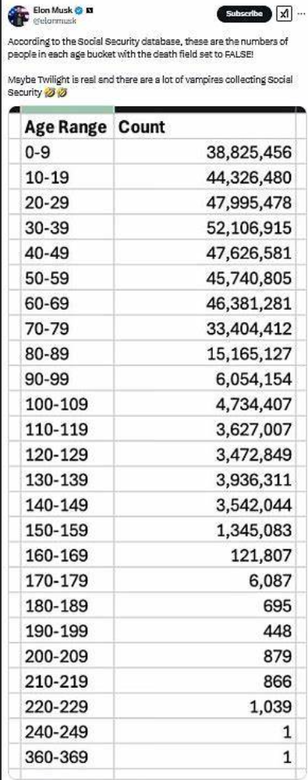
American Republic vs Global American Empire
A Tale of 2 Governments living in 1 Country

These revelations open a whole series of questions about the true nature of our Federal Government, its governing bureaucracy, and what’s really going on behind the scenes. One is reminded of the famous concluding scene from the Wizard of Oz, as Dorothy’s little dog unmasks the great Oz, “Pay no attention to the man behind the curtain…” If the initial allegations prove to be true it means close to a 1 trillion dollars has been mis-appropriated & stolen, yearly. By whom? Usually by those yelling and screaming the loudest against transparency. And why are they screaming the loudest? It’s because they are benefitting for it. The responsible citizen must ask themselves, are we really sovereign, when theft and graft of such a vast scope, scale, and magnitude has been happening for so long? Concordantly, where are you in the seven stages of grief? Shock-Disbelief? Denial? Guilt-Bargaining? Sadness-Regret? Anger? Acceptance? or Hope? let the gravity of it all sink.

Ideally, we are someplace between “Acceptance,” and “Hope.” The gravity of this depravity is shocking. Daily we hear more, and more and there seems to be no end to it. We must accept the depth of this depravity and act accordingly to ensure the necessary cuts to the Federal Bureaucracy do come to pass. For those currently still serving in government office who oppose said cuts, be advised and warned. You are next.
For many people, these revelations convey the message that we have been living, in a hall of mirrors, where our political leaders, to varying degrees, are all sock puppets performing their assigned rolls whether that be Democrat or Republican style of kabuki theatre. The dynamics now are increasingly clear that an awakened population will not tolerate the uni-party kabuki theatre. President Trump’s Cabinet will be imposing the necessary capital controls on all the fraud, waste, and abuse. Congress must act accordingly; as we approach the next Congressional budget deadline for 2026 on March 14th 2025. We are waiting to see… Will Congress act like it did in December and present another 2,000 pages of fraud, waste, and abuse, or will the current level of DOGE’s work be enough to institutionalize programmatic cuts to the system, or will we land someplace in between?

During President Trump’s joint address to the US Congress, March 4th, he listed a number of these recent revelation’s courtesy of US AID. “100 Billion to finance illegal alien housing and food, 45 Billion to DEI (diversity equity & inclusion) scholarships in Burma, 100 Million to Egyptian Sesame Street Programming, 40 Billion to Pakistanis Trans Gender Studies, 40 million to help sedentary migrants, No one knows what that is, 8 million to help LGBTQI+ in African Nation of Lesotho,” “8 million for trans gender mice…” On the surface it looks, sounds, and feels absurd, but underneath we know; this is how the United State’s foreign policy machine works. Money is issued under various innocent, or not so innocent, sounding causes and sent to bribe and buy off governments globally to serve our economic and strategic interests. As we dig deeper, we will see there is no real distinction between the United State’s domestic and foreign policy. Our domestic spending and policy choices support our global affairs. The connecting tissue which has not yet been fully detailed, but stayed tuned, no doubt it’s coming soon, and will be the next big revelation.

Already a number of outspoken citizens like, Mike Benz ( About - Foundation for Freedom Online ), General Michael Flynn, among many others have spoken on this topic. In short, in order to manage global affairs, the United State’s Military and State Department’s have developed, over the last 80 years, the hard and soft power methods to manage populations which are not abiding by the Washington Consensus. What is the Washington Consensus? Writing in the early 2000s, Thomas P.M. described this machine in detail in his book and many video presentations, “The Pentagon’s New Map.” The powers that be view the world via the tensions between the operating core and the non-integrating nations. The operating core is the West broadly speaking, and the non-integrating gap are the areas of south American, Africa, Central Asia-Pacific, which don’t really abide by the Washington Consensus. Global conflicts tend to occur along the boundaries between these two geographies.

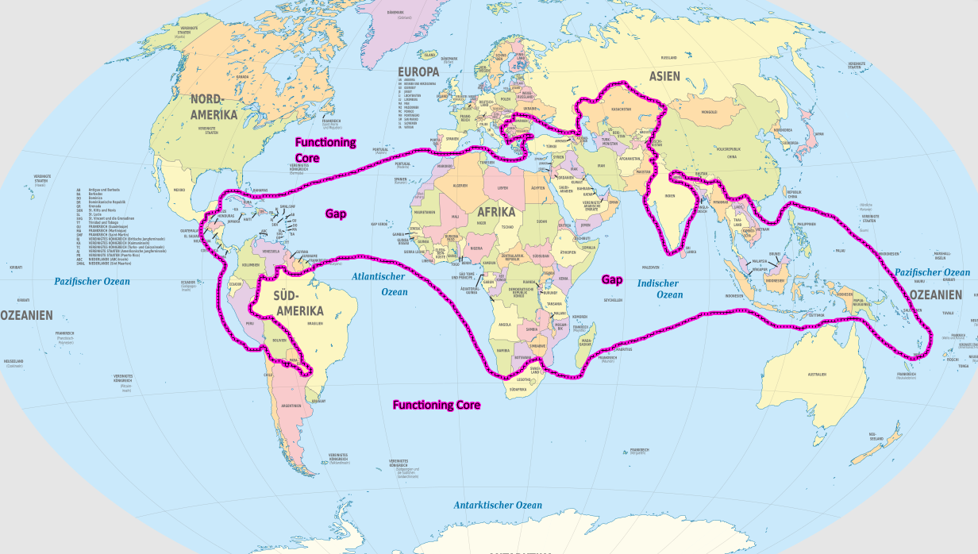
Thomas P.M. Barnett’s “Pentagon’s New Map”

Starting in 2016, during President Trump’s first term, the U.S. State Department’s and the Defense Department’s powers, which were formally outward facing, have been turned inward, and have been used against American Citizens. It’s only been through a series of miracles, which includes Trump surviving 2 assignation attempts and Elon Musk’s purchase of Tweeter (Now X social media platform) that Trump was elected and now his cabinet must correct these grievous errors in the American System. Money is essentially at the root of all of these abuses of state power. This money is a vast sum and previous to the efforts of DOGE’s audit this process has been unaccountable and, generally speaking, in accessible to the American Public. Take another recent revelation. EPA Cabinet Sec. Lee Zeldin & his team’s discovery of 20 Billion dollars associated with the Green New Deal was parked in an outside bank, offshore, and was being moved to finance various nefarious frauds, grifts, and politically-criminal activities.
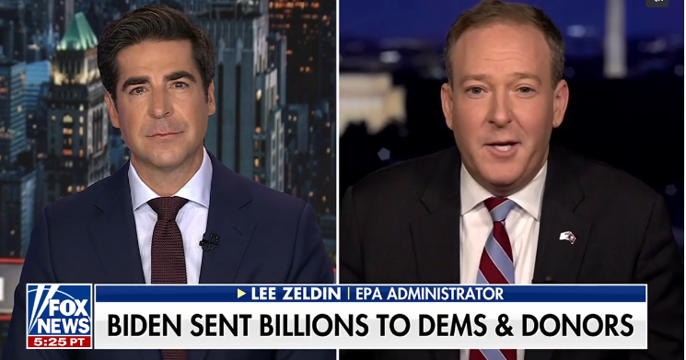
https://www.foxnews.com/video/6369704326112

Now, given all these revelations, the fight in Congress over the Federal Government’s Budget will be intense. Will Member’s of Congress try to sneak thru another bill full of grift like they did back in December, or will the new reality sink in and will Congress present a budget which more adequately reflects DOGE’s et al revelations? TBD? Pay close attention to the budget fight or continuing resolution (aka C.R.) vote on March 14th 2025.
This past week (3.8-3.14.25) in Congress & Capital Hill, US Federal District Judge Paul Engelmayer, in Washington DC challenged President’s authority on spending by ordering a reversal of certain budget cuts. The Supreme Court voted 5-4, with Justices John Roberts & Amy Coney Barret joining the liberal side asking the lower court for more specifics. ut Ultimately, this challenges President Trump’s executive authority, under the U.S. Constitution, see Article 2. This Constitutional power states, the President is the Chief Executive Officer, Chief of the Armed Forces, and Chief Magistrate of the land; and as further elaborated by the unitary executive theory, the President has power over all agencies which operate under the Federal Executive’s umbrella. Going forward it will be a legal battle to determine how and to what degree the money is or is not allocated. Will the President exercise an impoundment of the funds allocated by Congress, or will a recissions be ordered; and the said amount be withdrawn from the budget? However this shakes out, it’s an unprecedented situation. Despite the best efforts of previous Presidents (Eisenhower, or Clinton, or Obama) the Federal Bureaucracy has never been substantially reduced; and has only grown since it initial creation by President W. Wilson, 100 years ago, into the bloated behemoth we have today.

New World Financial Order

Assuming President Trump et all will win and successfully implementation these changes, what does this portend for the United States and the globe? Let’s elaborate and lean in on the press activity of Treasury Secretary Scott Bessent, to assist us in detailing out the process moving forward. Last week at NYC’s Economic Club, and on CNBC, Treasury Secretary Scott Bessent outlined the harmony of interests which Team Trump is pursuing between the executive & legislative branches of government. It’s an epic rebalancing act, aimed to return the US economy to normal; entailing massive reduction of government splurge-spending & prioritizing private spending, without killing the economy.
To accomplish this Herculean lift, there must be a coordinated effort between those in the Congress who craft the President’s Budget and those in the Executive who enforce MAGA & MAHA policy objectives. Secretary Bessent successfully detailed how tariffs are both short-term negotiating tactics with an aim toward rebalancing bi-lateral trade relations between the United States and its various trading partners (Mx, Ger. Eng., Fra., Ca., China etc…). In short, we demand, an end to various things happening in Mexico and Canada, for example fentanyl production & distribution, and if those governments don’t comply; they will suffer economically from higher tariffs. In a funny way, many Canadian Citizens, just like Californian residents, have already voted with their feet, and left Canada, or California, for the more welcoming economic climates in Texas & Florida. The key to success here are for the “BIG 6, “ to be working together to craft and implement these policies together, mass media critics be dammed. The BIG 6 are: Treasury Sec. Scott Bessent, Office of Management & Budget Director Russ Vought, Senator Majority Leader Thuen, House Speaker Johnson, & National Economic Council Director Kevin Hassett & DOGE Elon Musk.
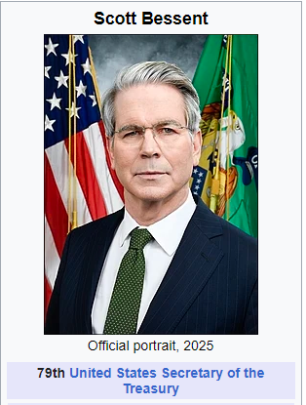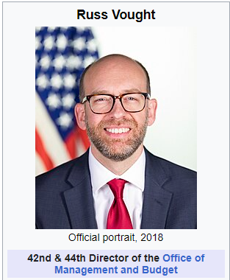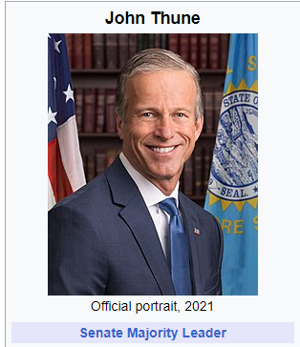
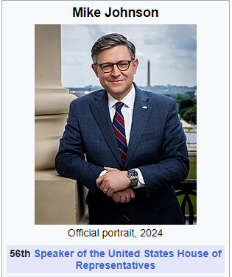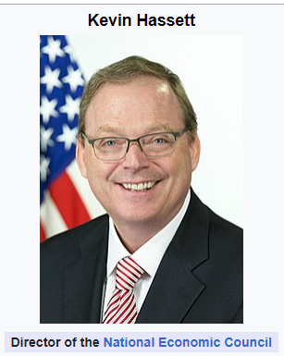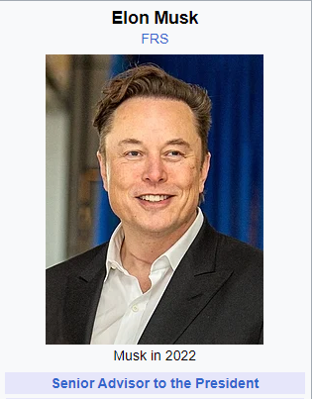

There are others playing supporting rolls, but focus on the “Big 6”. The 3 main policy objectives to accomplish within the context of a balanced budget and a massive spending reduction are the following:

- 100 % tax credit for all capital equipment & factory construction (limited time frame)
- remove excessive regulations
- full spectrum energy dominance a.k.a. drill baby drill.

Operating in tandem with these policy objectives are the efforts to collect more revenue from tariffs i.e. “Office of External Revenue,” and a fundamental restructuring of world trade relations, income generation, and labor relations. Already President Trump has secured 1.5 trillion in foreign investment commitments from Apple, TSCM, Soft Bank, Honda, and others to invest in plant and equipment in the domestic United States. Almost simultaneously in response to the news of these new investments, the stock market voiced it’s dis-approval and market values fell by approximately 1.4 trillion in market value, in the past few weeks. This market adjustment is a response to the beginning of a return of America as a techno-industrial domestic power, whose focus will be on internal domestic improvements and prestige abroad. This idea is a recreation of an old theme, with deep roots in the United States.
Larry Kudlow remarked on all the texts he is receiving from President Trump regarding former President William McKinley. For those of us in know, President McKinley was the last active representative of the American System of Political Economy and it was only his assignation, in 1901, which ushered in a decade later, British laissez-faire law-less-ness in America which led to the great panic of 1908 and incidentally the Progressive Era of Woodrow Wilson.

“Free trade gives to the foreign producer equal privileges with us. It invites the product of his cheaper labor to this market to destroy the domestic product representing the higher and better-paid labor of ours. It destroys our factories and reduces our labor to the level of theirs.”
-President McKinley 1892 speech in Nebraska

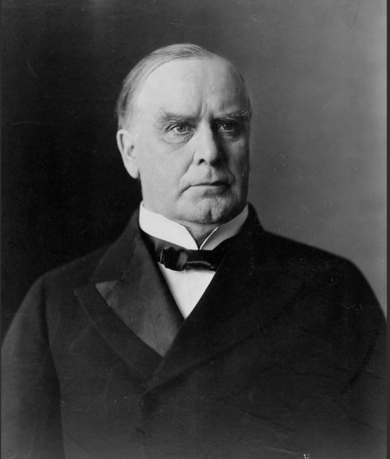

“Free trade cheapens the product by cheapening the producer. Protection cheapens the product by elevating the producer. The protective tariff policy of the Republicans... has made the lives of the masses of our countrymen sweeter and brighter, and has entered the homes of America carrying comfort and cheer and courage. It gives a premium to human energy, and awakens the noblest aspiration in the breasts of men. Our own experience shows that it is the best for our citizenship and our civilization and that it opens up a higher and better destiny for our people."
-President McKinley

All these shout outs to President McKinley are great and historically illuminating for us in the cognoscenti, but for the run of the mill American whose 401k, or pension funds, and/or financial portfolios maybe be wrapped up in a global-financial-markets; therefore there are significate financial interests with mixed feelings, and well, be prepared for extreme market volatility. Given the ongoing budget deliberations coming and the nature of the policy changes proposed, those interests should brace for impact and immediately make necessary adjustments. Invest in America.

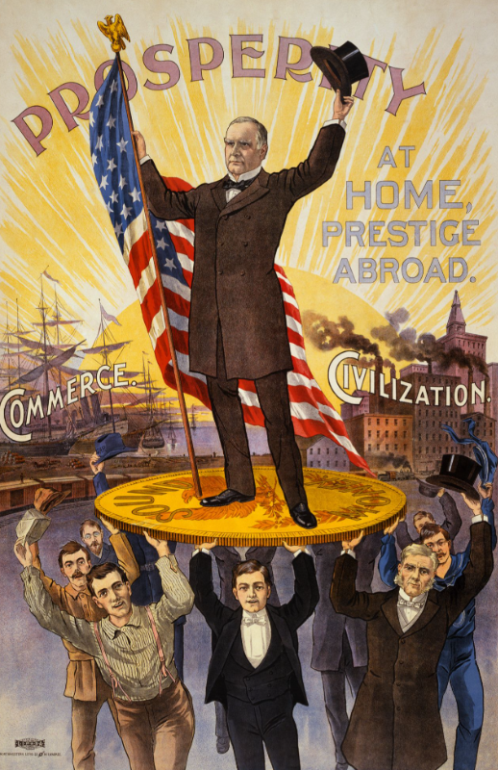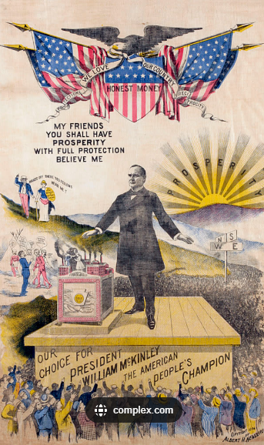
https://potus-geeks.livejournal.com/1771378.html

Larry Kudlow also observed that Free trade, Ricardo’s concept of comparative advantage, and the World Trade Organization et al do not consider the domestic and cultural policies which differentiate other polities. Kudlow stated the, “United States is a democratic republic with a Bill of Rights; whereas China is a despotic-authoritarian regime” ... Bravo Larry, what other nation on earth has a bill of rights that guarantees Freedom of Speech and the Right to Bear Arms? Eureka, you finally figured it out! The conversation concluded, with the challenge to refocus the domestic U.S. economy to get off of rampant government spending and focus on prioritizing the private sector. Kudlow described, “when complete, this model will be a model for the world to emulate,” to which Treasure Sec. Bessent responded, “Larry everyone knows what should be done, but they don’t do it, because they lack the will power.” Bessent concluded, “How are we going to get this deficit down…? I have been thinking about this non-stop for a long time…We will be de-leveraging government spending and re-leveraging the private sector, and getting our private-regulated banking system going again.” A “regulated banking system,” means a repeal of the Graham-Leach-Bliley Act of 1999 and a return to the Glass-Steagall act aka the Banking Act of 1933. Huge!!!

Return to, American System of Political Economy

Treasury Secretary Bessent’s dialogue with Larry Kudlow indicates that the Trump Administration is exercising a whole of government approach to return the Federal Government to it’s founding operating principles which were best expressed historically by Alexander Hamilton with re-iterations and modifications by John Quincy Adams, Andrew Jackson, Henry & Matthew Carey, Lincoln-Grant-McKinley, and to varying degree both Roosevelts (Teddy & FDR). A historical study of each will find, that each in their time, used Constitutional powers of our republican system to promote the general welfare to meet the economic and strategic challenges of the times. To distill the governing principles from Hamilton’s three reports to Congress in 1789 on “Useful Manufacturers,” “Subject of Credit & Debt,” and “National Banking,” our general principle and mission is to use the money system and the organs of governance to improve the physical living standards of American Citizens and to protect those standards from monopoly and imperial designs.

Early in our republic’s history, we were very much under threat from the Monarchies of Europe and the depravities of living on the frontier. Ultimately, the War of 1812 and later the US Civil War 1856 settled the question of imperial conquest definitely; the United States would never be conquered by an invading power. A century of growth moving west with a series of land acquisitions and internal improvements powered first by Conestoga Wagons, next by steam boats, and next rail roads, steal development, oil refining and today via nuclear power and advanced rocket design. Our young republic grew in strength by the ability of man to implement scientific discoveries and inventions to tame nature and provide a secure living for its citizens coast to coast.

Today, in our time the major problems in the system have to do with waste, fraud, and abuse of the Federal Government’s spending powers & entitlements; which have been focusing on managing global affairs under the mission of Globalization. Yes, we inherited great global power and responsibilities from our victories during World War II, but increasingly, since 1945, our powers have been mis-used and perverted by those entrusted with their use. The findings from DOGE outline, day by day, trillions of dollars of fraud, waste, and abuse stolen by those both elected to the US Congress and by those running our Federal’s Government’s bureaucracy. They all must to held to account as we reorganize the American System of Political Economy to suite American Citizen’s needs.
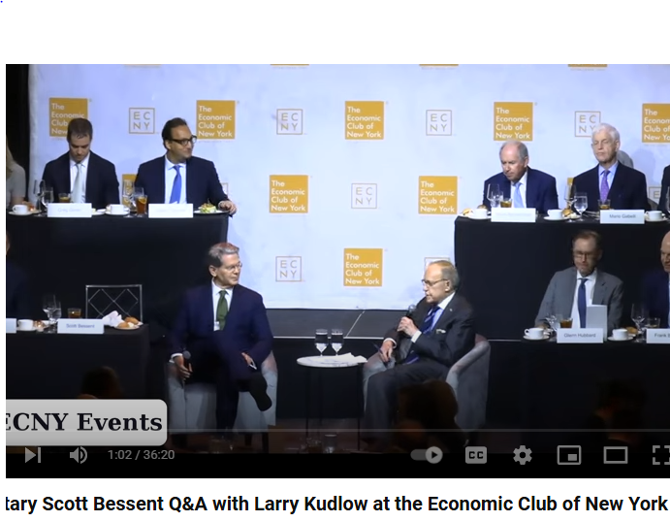
https://www.youtube.com/watch?v=Us6-x3kzaqI
CNBC interview with Treasury Sec. Scott Bessent
https://www.youtube.com/watch?v=CVa5MEnvShc
Ray Dalio speaking at CNBC Converge Live in Singapore “ we have a severe debt supply/demand problem.”
Ray Dalio warns that mounting U.S. debt problems could lead to ‘shocking developments’ – NBC Los Angeles

Sovereign Nation States

If successfully implemented domestically, globally this will mean a successfully shift in policy away from globalization and back to a world of sovereign nation states. The roots of this policy go all the way back to Cardinal Mazarin and Peace of Westphalia in Europe of 1648. This idea has had various forms of expression in France and England, but really only took long term hold with the founding of the United State as a Constitutional Republic in 1789. The conclusion of WWII and the signing of the United Nation’s founding charter were intended to continue this principle but other actors and interests usurped the idea.



Pictured above the dignitaries of Europe who signed the Peace of Westphalia in 1648, ending Europe’s 30 Years War
Link below to read original text of the Peace Treaty of Westphalia
https://pages.uoregon.edu/dluebke/301ModernEurope/Treaty%20of%20Westphalia%20%5BExcerpts%5D.pdf
In short, a nation is the most efficient unit of a people and may not be interfered with, nor coerced by other powers. Authority and sovereignty is defined by the people living within the bounds of said nation. Admittedly, we in the United States have not lived by this rule too closely since the end of WWII. In the context of the Cold War, 1945-1989, agents of the CIA & State Department have a long not so secret history, of entanglements and skullduggery in the politics of other nations which includes; overthrowing governments, and grabbing resources. Perhaps we have an opportunity now to revisit this question of integrity, policy, and the management of our global affairs more clearly; as we renew our commitments. President Trump’s message to the European Union, to pay for you own defense and increase their military’s size and scope is part of this shift. If a nation and its people are to have sovereignty, they must be strong enough, by their own means to protect themselves. As the roman proverb states, “those who wish to live in peace must prepare for war…” Cato the Elder, “Si vis pacem, para bellum.”
Therefore, we should expect other nations to expand their military powers and for institutions like the European Union, to de-centralize more of its powers to its member states, to enable the citizens of Germany, France, England to exercise more control over their domestic affairs.

Words Talk Numbers Scream! Part2
An American Citizen’s Narrow Path to Knowledge…exercise the Body & Mind
At the conclusion of the World War II and the signing of the Bretton Woods Agreements, the victor nations, were all sustained by the United State’s economy, government, and our citizenry. America inherited global economic and military powers with responsibilities far beyond our means to digest and manage. For better or for worse, the management of global affairs, filtered through the United Nation’s Security council and our Military and State Department, and these institutions boiled down the complexity of life to a binary choice of capitalist or communist, are you with the United States and our Western NATO allies, or the Soviet Union and the Warsaw Pact allies. A third faction of non-aligned nations emerged later, but with respect to economics, strategic issues, and global developments; things were stuck in a binary choice-paradigm until the Soviet Union’s collapse in 1991. Between then and now, 2025, we in the United States have been suspended in a kind of crisis management state of paralysis, with our leaders unable to break free from this binary Cold War paradigm. After the Cold War’s official conclusion in 1991, the powers that be wished to keep the old cold war party going by creating new-quasi-fake paradigms whether it’s the End of History by Francis Fukuyama or the NeoCon’s War on Terror et al… Now the game is up, and increasingly, the populist movement taking hold in the US & Europe will both purge the system of its political sophists and return to normal growth or face economic collapse and ruin. This populist movement needs a deep dive into the great cultural, scientific, and spiritual advances which signify the unique experiences of European extended civilization; and to that end I offer 13 chapters of study for reference and mastery.

- Ancient Greek World 360 BC Socrates, Plato, & Aristotle
- Early Christianity in Europe 0-400 AD
- Roman Republic & Roman Empire; 2 Part collapse in 400 AD & 800 AD
- Charles the Great & Europe’s first Modern Nation, France 700-800 AD
- 500 years of Crusades 800-1500
- Renaissance Italy 1511
- Coming to America
- Johannes Kepler & Modern Science 1630
- The American Experiment Begins 1630-1789
- German Renaissance Schiller & Goethe
- Music Renaissance Germany & Italy Bach-Beethoven-Verdi-Schumann-Brahms 1750-1890s
- Post WWII American & Cultural Revolution
- Concluding Thoughts & the American Promethean

- Socrates, Plato, & Aristotle
What is behind the binary choice of being liberal or conservative? Are there alternative points of view? Boil it down to its philosophical and epistemological roots and we have the question of a mind attempting to measure the universe. Is truth merely the impressions reported to our brain of the five senses or is it something further? The question is as old as time and goes back to the roots of our civilization and Ancient Greece.
Pictured below we have the 2 great philosophical adversaries from the Ancient Greek World, Socrates and Aristotle, debating the issue of truth and how best to organize society. The famous Italian Renaissance Artist Raffaello, aka Rafael, gave new life to this history in 1509-11 with is epic painting, “The Greek School of Athens,” which immortalized this discussion on the walls of the Vatican’s Sistine Chapel, in the, “Stanca Della Segnatura,” a.k.a the room of petitions & signatures. Pictured on the right, Aristotle proclaims, “truth comes from what I can see, taste, smell, and touch…Notice my out stretched hand…I’m feeling my way to knowledge, and I’ve written it all down in my book “The Ethics,” which I’m carrying here.” To which Socrates responds, “no, silly man, truth comes from the heavens, notice I’m pointing up to the universe, that is where we look to seek divine wisdom from god…and I have written it down in my book, “The Timaeus…” By examining their feet, we see Raffaello’s art captures his sense of humor too. Socrates is walking while Aristotle is standing still; were Aristotle to walk with Socrates, Aristotle would clearly drop his book.
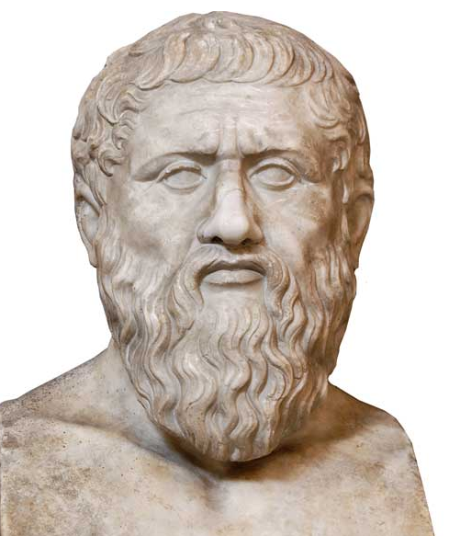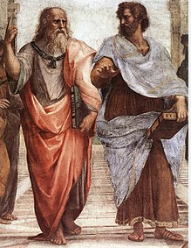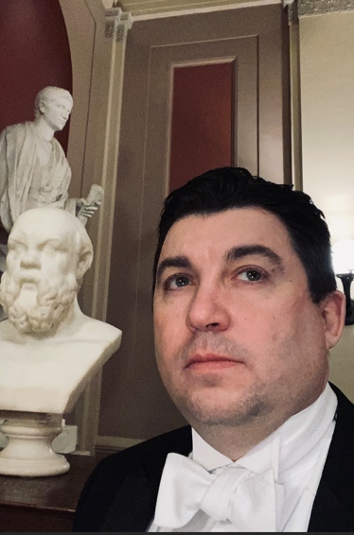
Plato Socrates vs Aristotle Octavian Cesar, Socrates, & the author

in Ancient Athens, the young aristocrat Plato, inspired by the many teachings of Socrates immortalized these lessons in the many dialogues a.k.a. “The Socratic Dialogues.” Plato’s main dialogues being, “The Timaeus,” “The Republic,” & “The Laws”. Here many fundamental questions were hashed out: love, virtue, honor, justice, knowledge, and most important, “what is virtue, and what does it mean to live a life of virtue?” Buried deep in “The Republic’s” Book 7, or 10, we find Plato’s notion of the divided line; a polemical poetic device he uses to describing knowledge or the varying degrees of knowing vs visual observation. Plato elaborates, thru his character Socrates, the line is divided into several parts. The first and smallest part of the line makes up what we can see, touch, hear, and/or taste. Here one knows by direct sense perception. Next, as we proceed further along the line, we have emotional qualities, which are things we cannot perceive directly. These are objects lie outside direct sense perception but are measurable by the emotions they stimulate like: love, hate, anger, greed, jealousy, melancholy etc… Next, further along the line, are objects susceptible of logic. These qualities may be induced, or deduced, but again are never directly perceived by the senses. Last, on this line are ideas of truth and principle, which are only known via thought; or derived by arriving at a higher hypothesis after dissuading a lower/original hypothesis, which we refer to as sufficient reasons. An example of sufficient reason could be what Leibnitz calls in geometry as, “least action”. For example, in geometry the circle, is the most efficient shaped form by the least material used; hence the term least action; it is sufficiently reasonable to describe a circle to be so.

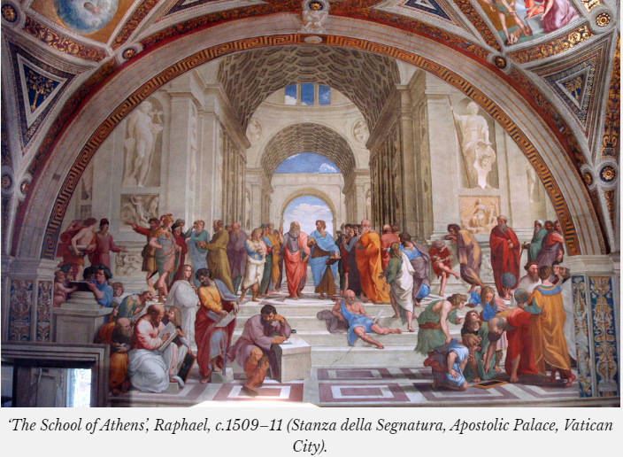

The Greek School of Athens, pictured above, depicts how Rafael saw these great ideas being hashed out in the ancient world. Included among the cast of characters are Pythagoras, Archytas, Archimedes, Tales, Alcibiades, among others… Inter-mixed within the painting are various non-Greeks, which you can see by their garments; a.k.a. they are not wearing togas (Donatello, Rafael, Leonardo Da Vinci). Also in this room, directly across the hall lies a similar painting also by Rafael which reflects the great discussion among the Christian world. Christ is pictured ascending into heaven and surrounded, “in the heavens” by various figures from the Old & New Testament. Below the heavens sits an alter with, ‘the monstrance’ and various theologians debating the transubstantiation, “Christs & the Eucharist”. The unleavened bread becomes the body and the wine, becomes the blood of Christ. Among the cast of theologians are: St. Augustine, Ambrose, Pope Julius 4th, Dante Alighieri, and St. Thomas Aquinas among others.

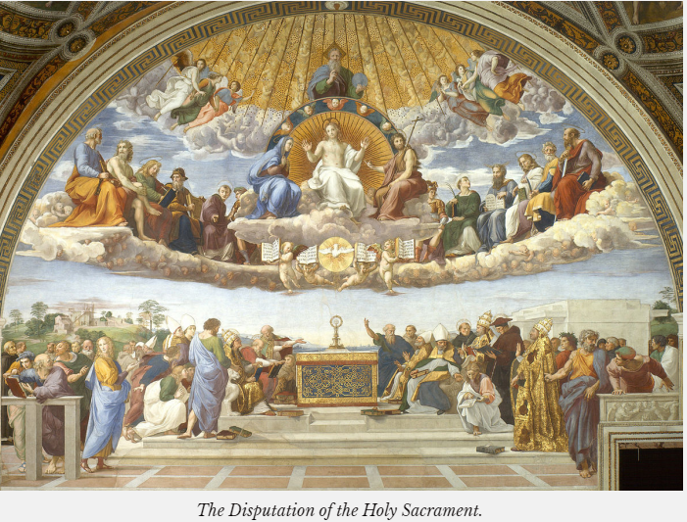
https://antigonejournal.com/2023/02/raphael-school-of-athens/
This work of timeless beauty was a product of the Italian Renaissance, 14th thru the 16 century, and was created by Europeans who, after years of contemplation of their roots, brought forth with great talents and contributions as we have summarily examined here. This is but the work of one Renaissance Man; there were many others. Also, bear in mind there were several rises and falls of civilization already, but this his contribution was a high point in the revival of human talent and agency to bring forth beauty and the sublime within each human soul.
The answers to many modern problems may lie in solutions the ancient’s figured out long ago. As one considers these fundamental questions: man’s relationship to other men, man’s relationship to the divine, and the miracle of Christ’s Ministry; one may come to understand certain universal principals. The human condition is both divine and animal and at our best, we can participate with the Divine thru the creative powers of reason and God’s grace. Individually just thinking great thoughts alone, or individually believing great beliefs isn’t sufficient; it’s thru the fruits of both our faith and labor combined with God’s Grace that true faith is manifested in human civilization.

